Lab 2

Name : Abubaker Attique

Roll number : P20-0560

Lab 1

#include <iostream>

using namespace std;

int main() {

char x;

x='a';

cout<<"The character is: "<<x;

return 0;

}

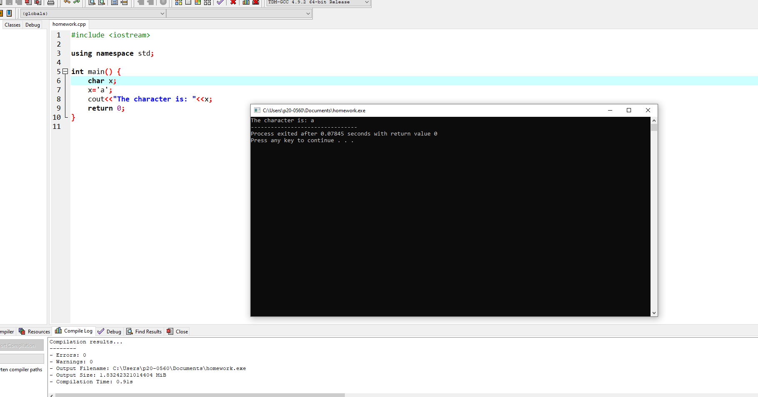

Lab 2

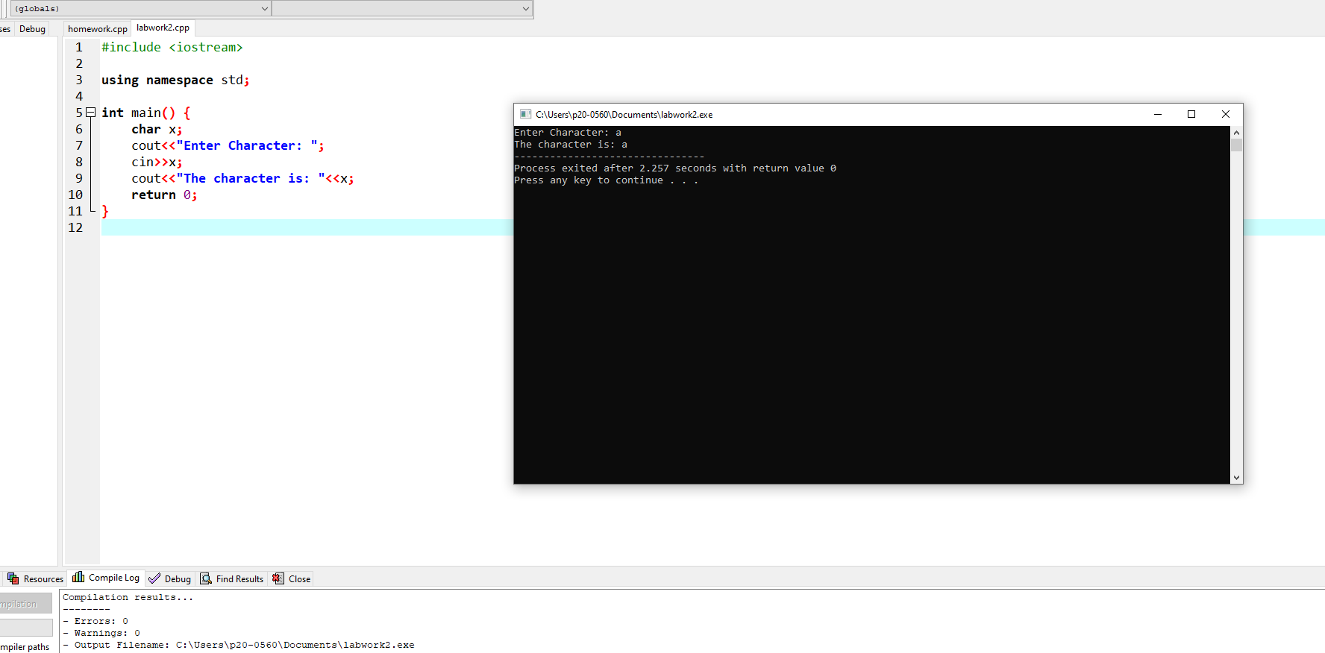

#include <iostream>

using namespace std;

int main() {

char x;

cout<<"Enter Character: ";

cin>>x;

cout<<"The character is: "<<x;

return 0;

}

Lab 3

#include <iostream>

using namespace std;

int main() {

char x;

cout<<"Enter Character :";

cin>>x;

cout<<"ASCII Value: "<<int(x);

return 0;

}

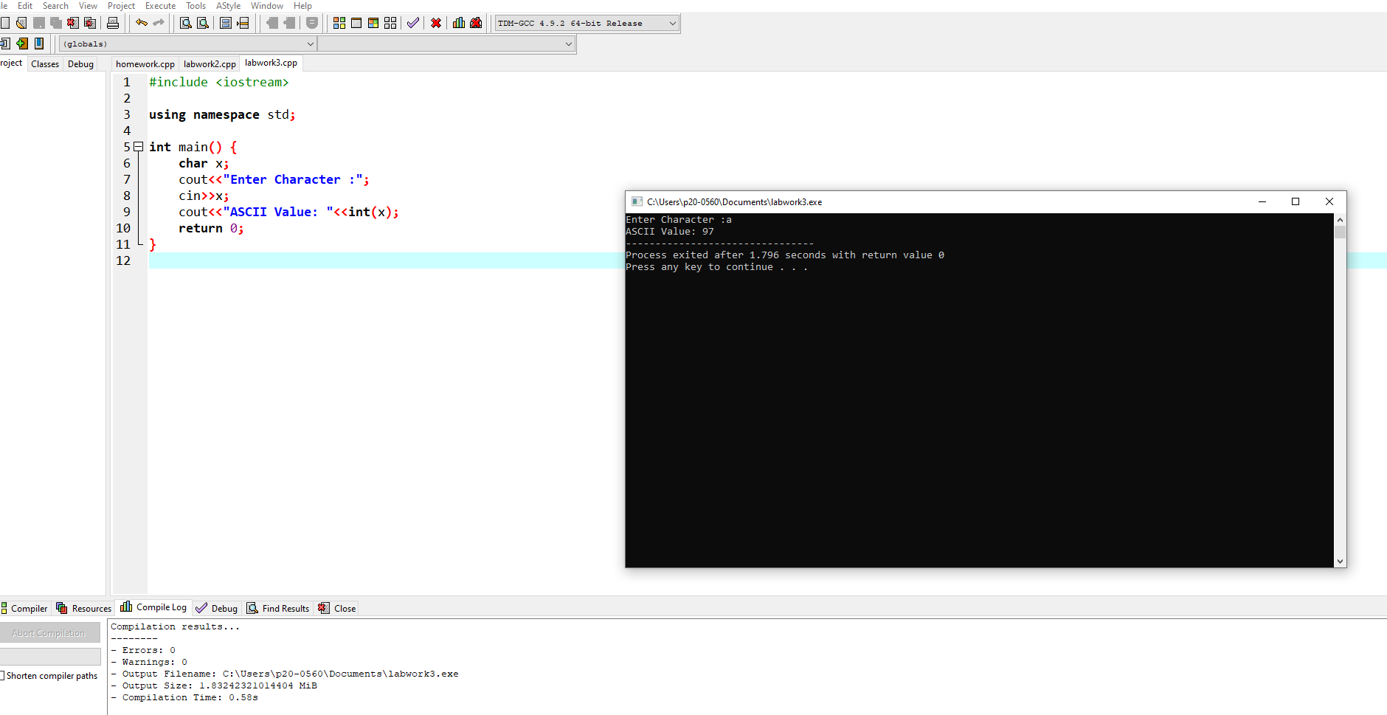

Lab 4

#include<iostream>

using namespace std;

int main()

{

int x,y;

cout<<"Enter Two number";

cin>>x>>y;

if(x==y)

{

cout<<x<<" is equal to " <<y<<endl;

}

if(x!=y)

{

cout<<x<<" is not equal to "<<y<<endl;

}

if(x<y)

{

cout<<x<<" is less then "<<y<<endl;

}

if(x>y)

{

cout<<x<<" is greater then "<<y<<endl;

}

}

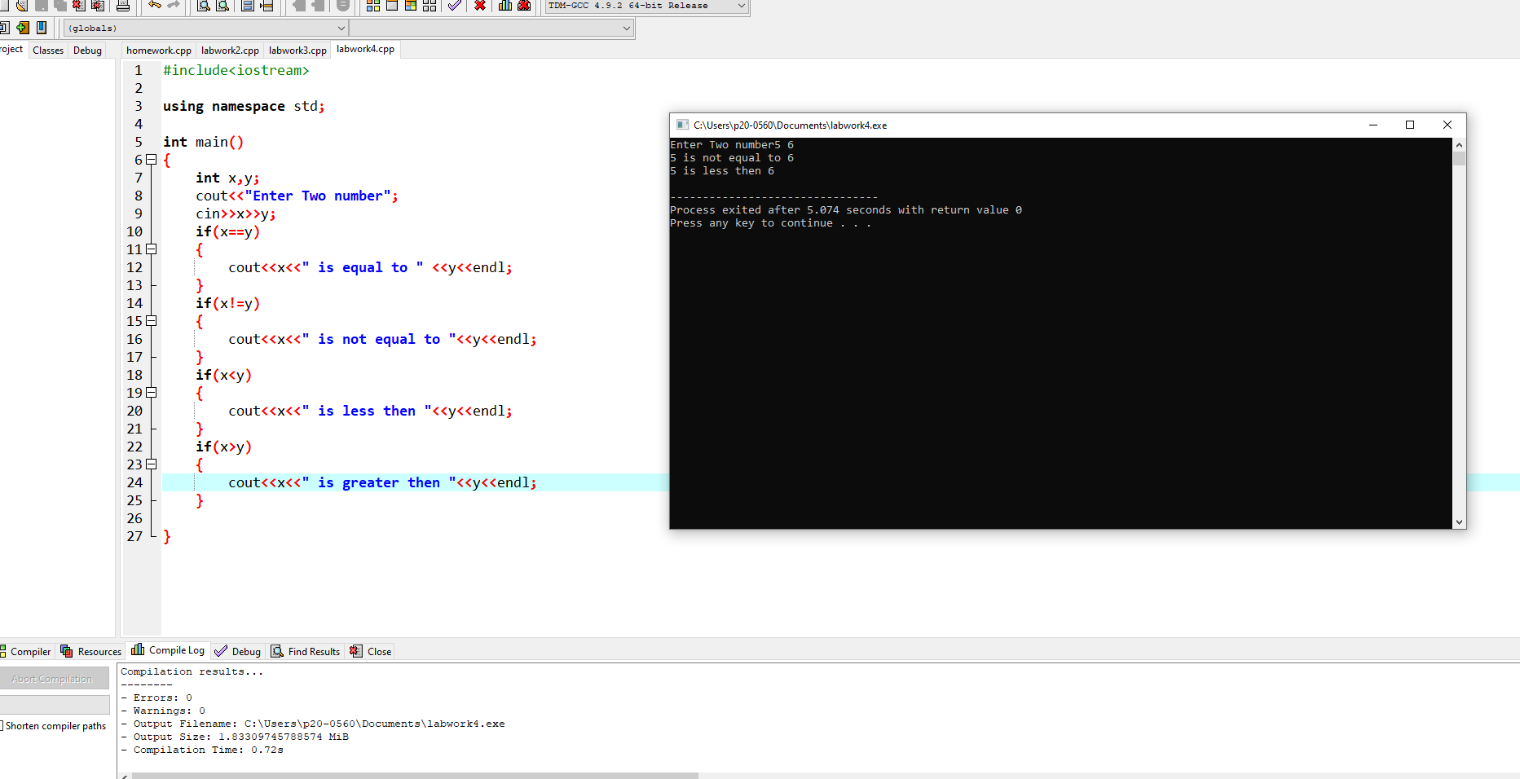

Lab 5 (using if and else statements)

#include<iostream>

using namespace std;

int main()

{

int num;

cout<<"Enter your grade: ";

cin>>num;

if(num>=50)

{

cout<<"Congratulation you are passed";

}

else

cout<<"You are failed";

return 0;

}

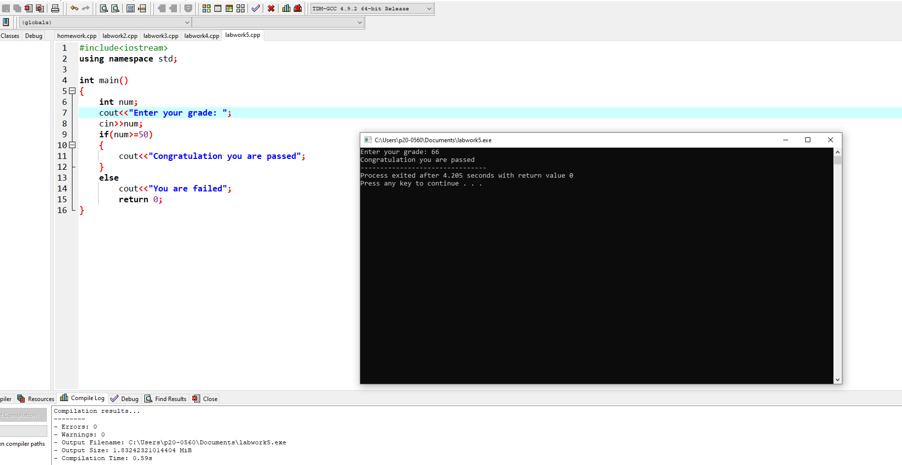

Lab 6

#include<iostream>

using namespace std;

int main()

{

int num1,num2;

cout<<" Enter first number :"<<endl;

cin>>num1;

cout<<"Enter the second number"<<endl;

cin>>num2;

if(num1 >num2)

{

cout<<num1<<" is greater "<<endl;

}

else

cout<<num2<<" is greater "<<endl;

}

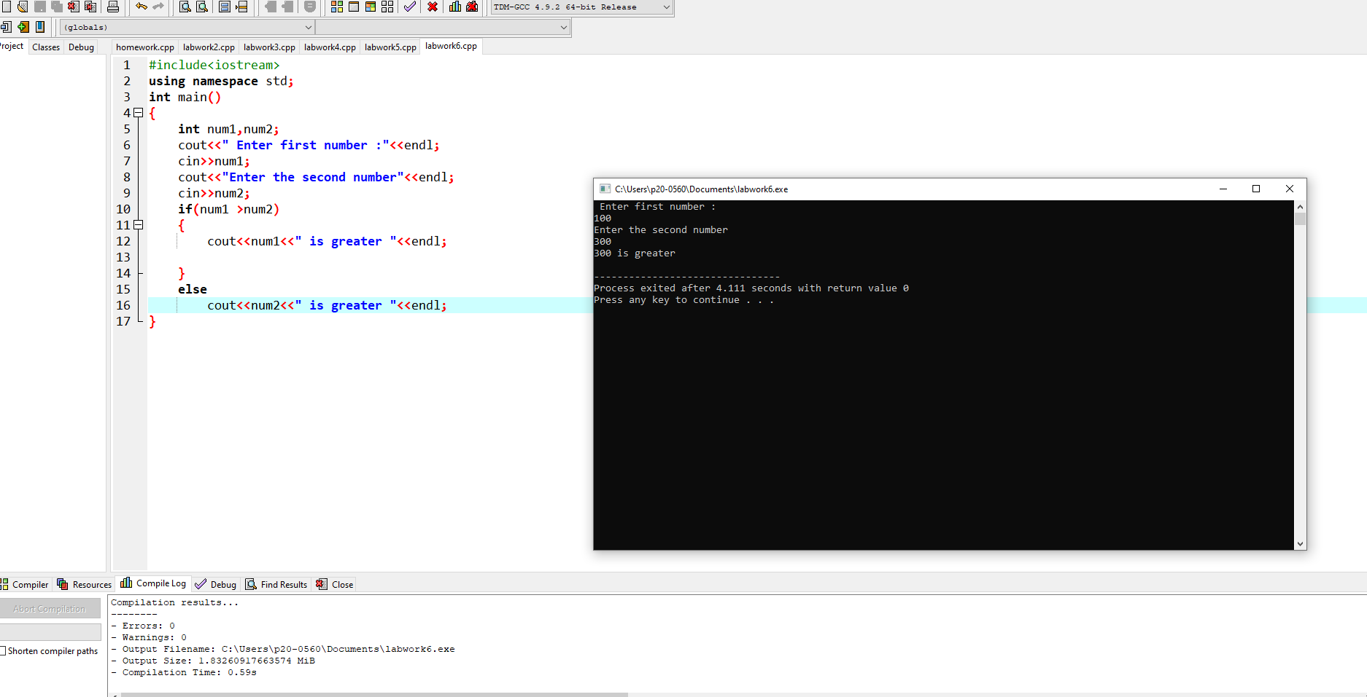

Lab 7 (Ternary operator (condition ?””:””)

#include<iostream>

using namespace std;

int main()

{

int num1,num2;

cout<<"Enter first number";

cin>>num1;

cout<<"Enter second number";

cin>>num2;

cout<<(num1>num2 ? "First Number is greater" : "Second number is greater");

}

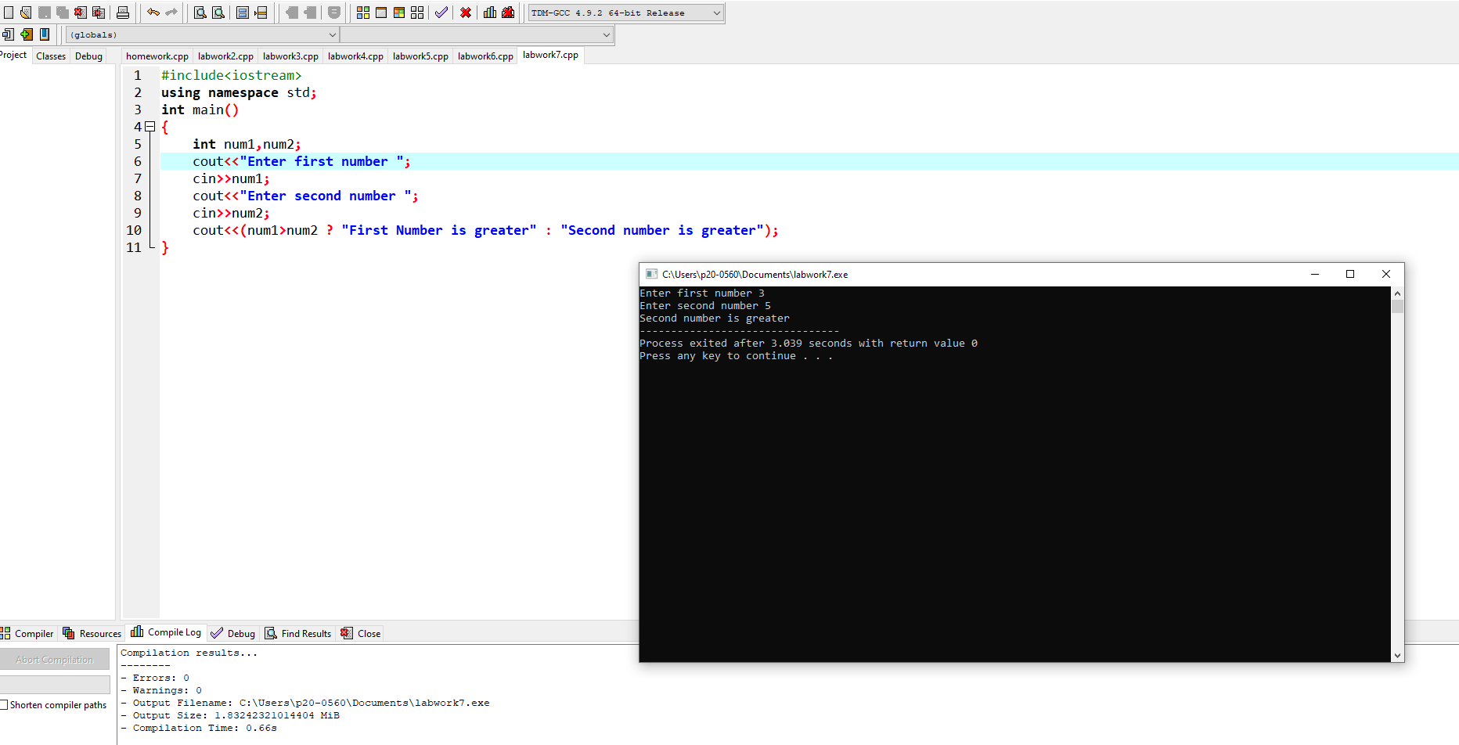

Lab 8

#include<iostream>

using namespace std;

int main()

{

char grade;

cout<<"Please enetr your grade ";

cin>>grade;

switch(grade)

{

case 'A':

cout<<"Excellent";

break;

case 'B' :

cout<<"Very Good";

break;

case 'C' :

cout<<"Good";

break;

case 'D' :

cout<<"poor";

break;

case 'F' :

cout<<"Fail";

break;

default :

cout<<"Enter your grade from A to F";

}

}

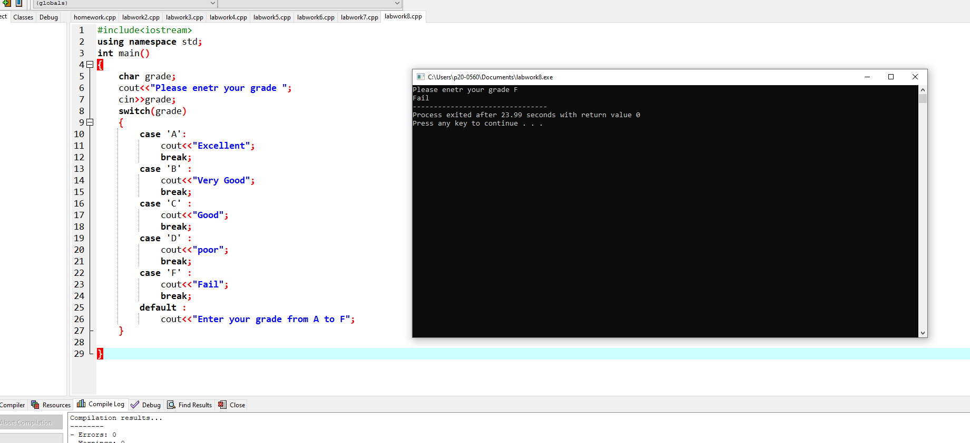

FINAL

#include <iostream>

using namespace std;

int main()

{

int num1,num2;

cout<<"Enter number"<<endl;

cin>>num1;

cout<<"Enter number"<<endl;

cin>>num2;

cout<<(num1>num2 ? "Greater" : "Smaller");

return 0;

}